ITP 359
Summer 2024

Homework 7
20 points
Generative adversarial network

Use a GAN to generate ‘apparel’ based on MNIST fashion dataset.
2 points each
- Use keras to download the fashion MNIST dataset directly.
keras.datasets.fashion_mnist.load_data()

- Visualize 25 apparel from the train dataset.
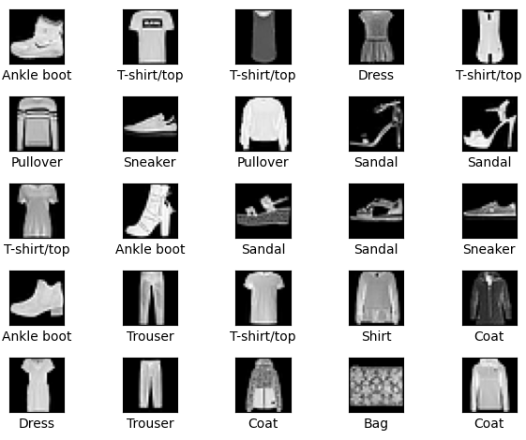
- Flatten and scale the train and test images.
- Build the generator and discriminator networks.
- Choose appropriate hyperparameters.
- Build the GAN network.
- Train the GAN network with at least 50 epochs.
- Plot the loss curves for the discriminator and generator.
- After the GAN is trained, generate and visualize 64 apparels.
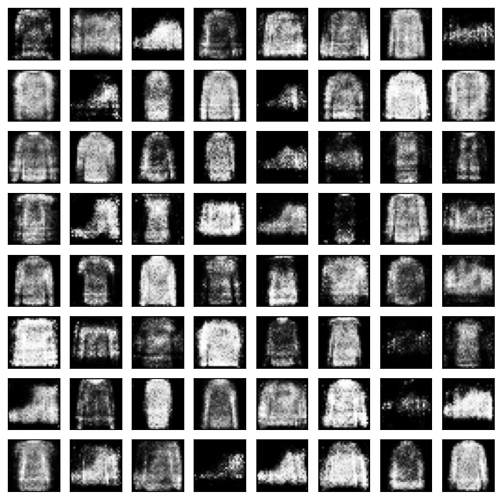
- Comment on the generative quality of these fashion items!

Please only submit the Python notebook. Be sure it has outputs.

